Von Neumann architecture, also known as Von Neumann model or Princeton architecture is a computer architecture that aims to store programs. Unlike fixed program computers, computers with fixed programming (ex. calculators), Von Neumann architecture is considered a stored program computer. In the Von Neumann architecture, programs or applications are stored into the memory of the computer, allowing it to function with multiple different types of programs. Von Neumann architecture is still used today and consists of four different components in the most basic form: the Input/Output (I/O), the arithmetic logic unit (ALU), the control unit (CU) and the main memory.

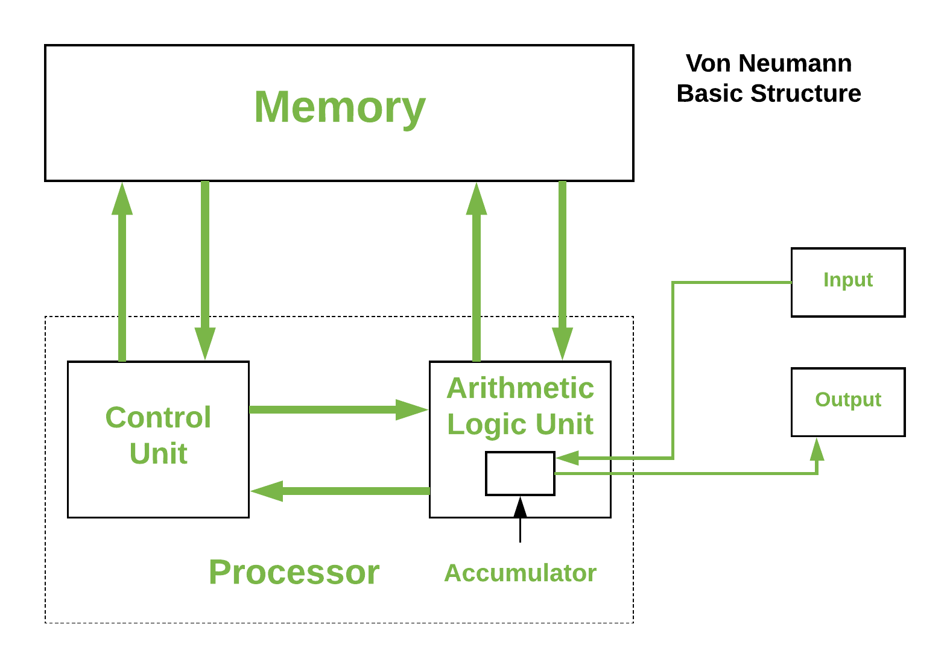

The Inputs and outputs is, as the name implies, takes the input from the user and after processing will output. The inputs and outputs go through the ALU. The ALU performs arithmetic and bitwise operations on integer binary number aka it performs operations on data. It takes inputs called operands then performs the operation on the data, then gives out the output. The main memory or simply memory stores the data and instructions as binary numbers. The CU controls the tells memory, the ALU, and the input and output how to respond through instructions. In modern use of Von Neumann architecture combines the CU and ALU together along side registers, small quick data storage within processor, to make a unit called CPU (Computer Processing Unit).

One important side note is that the CPU runs at a clock speed. These system clocks provide timing signals to synchronize circuits. The CPU runs at a specific frequency and the system clock is raised to this rate by the processor, giving the clock speeds (Hz). The CPU needs a certain amount of clock ticks/cycles per instruction. The higher the clock speed the more ticks/cycles the CPU can use per instruction. These ticks or cycles are called instruction cycles or fetch-execute cycles.

The fetch-execute cycle consists of three steps: fetch, decode and execute. First fetch stage, when the next instruction is retrieved by the CPU from memory or from the memory address and stored in the instruction register. Then the decode stage, where the instruction is broken down and decoded to determine what the instruction is and what data is being used. Lastly, after the CU decodes the instruction it passes the decoded data to the ALU to perform mathematical or logic functions on them. Depending on the instruction the ALU may store the output or send the output to the output device. Then the cycle repeats.

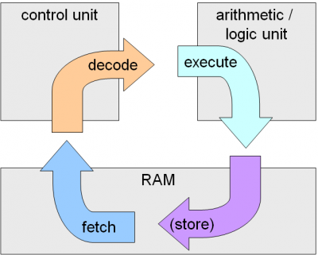

Wikimedia Foundation. (2021, April 21). *Von Neumann architecture*. Wikipedia. https://en.wikipedia.org/wiki/Von_Neumann_architecture.